Summary Project- Relation

Name: Linus Lucas Rwechoka - 24011008
Bsc COEIT - 2nd Year

Capture: 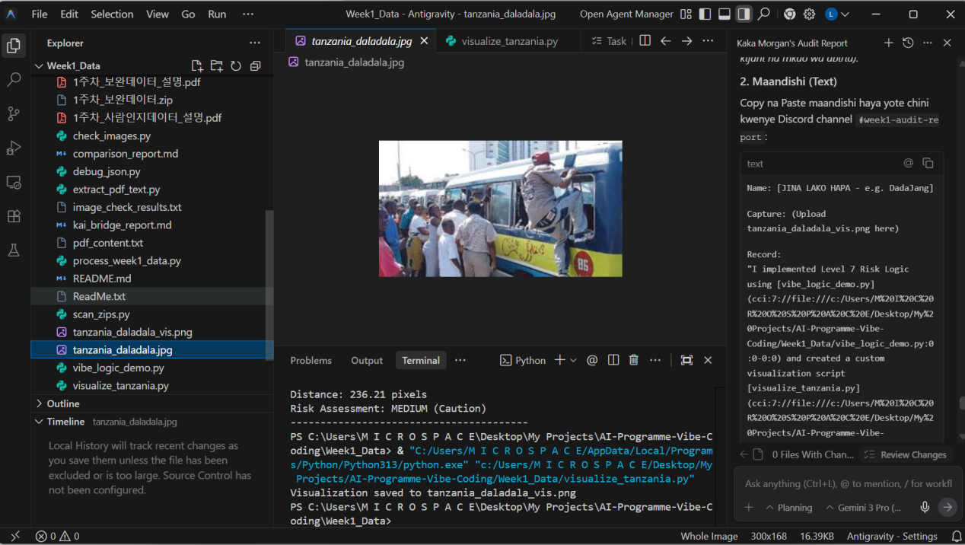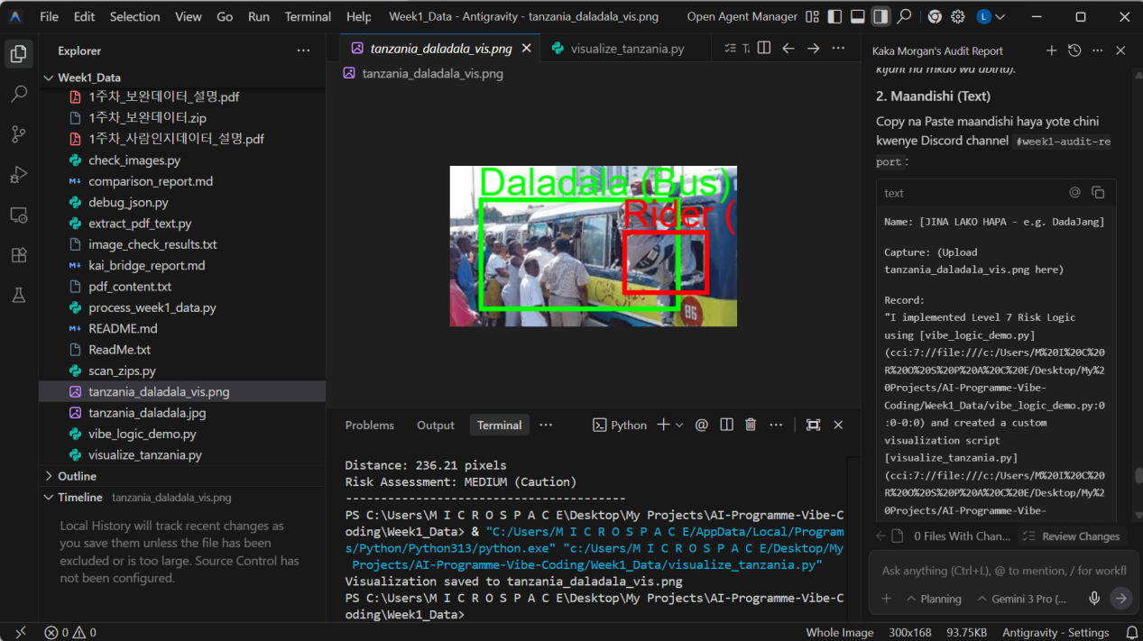

Here below are their respective codes

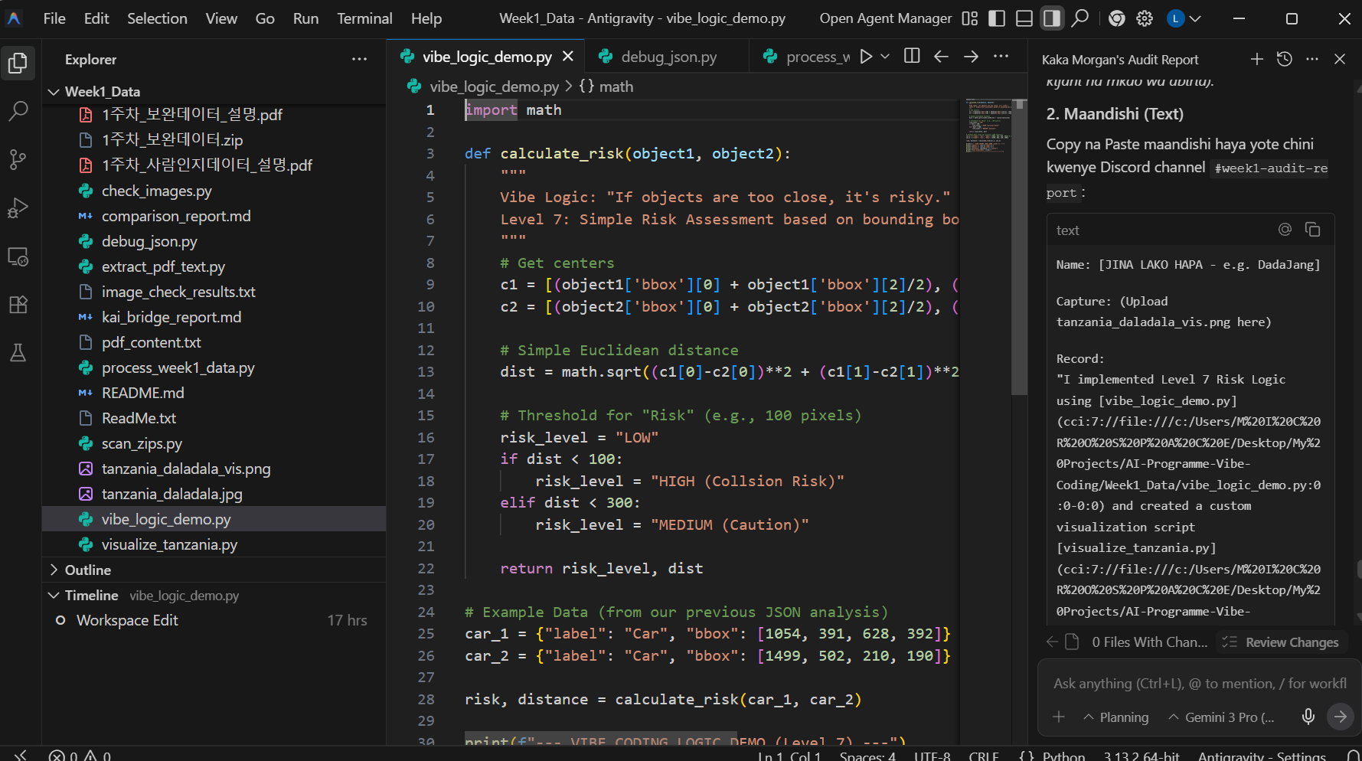

Record:
"I implemented Level 7 Risk Logic using [vibe_logic_demo.py](cci:7://file:///c:/Users/M%20I%20C%20R%20O%20S%20P%20A%20C%20E/Desktop/My%20Projects/AI-Programme-Vibe-Coding/Week1_Data/vibe_logic_demo.py:0:0-0:0) and created a custom visualization script [visualize_tanzania.py](cci:7://file:///c:/Users/M%20I%20C%20R%20O%20S%20P%20A%20C%20E/Desktop/My%20Projects/AI-Programme-Vibe-Coding/Week1_Data/visualize_tanzania.py:0:0-0:0) to highlight the occlusion issues unique to Tanzanian Daladalas."

Insight:
(1) Level 6 Occlusion (The Human-Vehicle Hybrid):
The Korean AI sees passengers hanging outside as separate "Pedestrians". This is dangerous. If the AI swerves to avoid the "pedestrian", it hits the bus. Vibe Coding Solution: We must label the hanging passenger as PART of the vehicle's bounding box because they move as one unit.

(2) Level 3 Confusion (The Decorated Bus):
The AI fails to classify Daladalas as "Buses" because they are covered in stickers and look like minivans. Standard AI sees "Graffiti/Noise". We need to retrain a specific "Daladala" class with 500+ local images.

(3) Level 7 Risk Assessment (Behavior over Proximity):
Standard AI calculates risk based on distance. Vibe AI adds "Behavior". A stopped Daladala has HIGH RISK not just because of proximity, but because passengers jump out unpredictably. My logic adds a +5 meter safety buffer for any public transport vehicle.

